Data Relationships
VPro relies on the use of relationships between tables. At the heart of these relationships is the project structure. It is here that we store data in individual tables that encompass a data type.
The table names are divided into two parts, the first being the project name and the second being the table type descriptor. The two parts are separated by the underscore character.
The tables are joined by relationships. The relationships have features such as types and events. For example the environment table – identified by the table name with the _Env suffix – is related to the mineral table in a one-to-many type of relationship – one plot can have many mineral soil layers. It has events that help to maintain this relationship by, for example, if a plot number is changed in the environment table, all of the related records in the mineral table will updated and thus maintain referential integrity. These events also prevent orphaned records by cascading deletions of related records. Delete a plot in the environment table deletes related records in the tables related to it.
VPro manages the relationships within a project and occasionally checks to ensure that the relationships haven’t been broken. The user should never have to create or repair a relationship.
Fig. 1 the project data structure
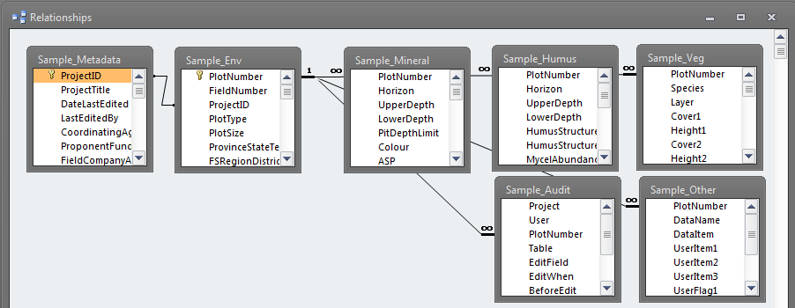

There are other, looser relationships between tables that the user creates to accomplish tasks such as grouping or splintering plots. In most of these instances referential integrity is neither defined nor enforced. For example a user may create a lumping table – there is a VPro tool for that – to combine certain species. This type of relationship would be applied for a task such as creating a summary where the user was interested in less detail. The relationship is never formally defined.
To enable these types of relationships, the user should never need to use the relationship editor. By simply selecting the optional table, VPro will know when and how to apply it.
Fig. 2 user enabled relationships
